Team Socrates & Team Sky
Layer 1: Teacher Approval Layer
- View student attendance requests — Teachers can see all incoming requests submitted by students along with their details.
- Review submitted reason and documents — Teachers can read the student's reason and open any supporting documents attached to the request.
- Accept or reject requests — Teachers decide whether the request is valid and approve or deny it accordingly.
- Add comments on approval/rejection — Teachers can leave a note explaining why a request was accepted or rejected.
- Forward approved requests to HOD — Once approved by the teacher, the request is automatically sent to the HOD for final sign-off.
- View past request history — Teachers can look back at all previously processed requests for reference or audit.

Layer 2: HOD Approval Layer
- View teacher-approved requests — HOD sees only the requests that have already passed the teacher's review.
- Perform final approval or rejection — HOD gives the last word on whether the attendance exemption is granted.
- Add final remarks — HOD can attach a closing note or instruction to the approved or rejected request.
- Maintain approval records — All HOD decisions are saved and stored for institutional record-keeping.
- Forward approved requests to faculty — Once the HOD approves, the request is pushed out to all relevant faculty members.

Layer 3: Faculty Attendance Layer
- Receive notification of final approval — Faculty get a real-time alert when a student's request has been fully approved.
- View approved requests — Faculty can see the list of students whose attendance requests have been cleared.
- View approval remarks — Faculty can read the comments and remarks added by the teacher and HOD.
- Mark attendance for approved students — Faculty update the attendance record to reflect the approved exemption.
- Maintain attendance update logs — A log is kept of every attendance change made, ensuring a clear audit trail.

Tech Stack
Frontend:
- Flutter (Mobile Application UI)
- Nextjs (frontend)
Backend:
- FastAPI (API development)
- Python (Core backend logic)
Development Tools:
- GitHub (Version control)
- Postman (API testing)

Advanced Requirements:
- Real-time notifications to teachers, HOD, and faculty
- Request tracking status (Pending → Approved → Completed)
- Search and filter requests by student, date, or status
- Document upload and preview support
- Dashboard showing approval and attendance summaries
- Deadline or expiry system for requests

System Flow:
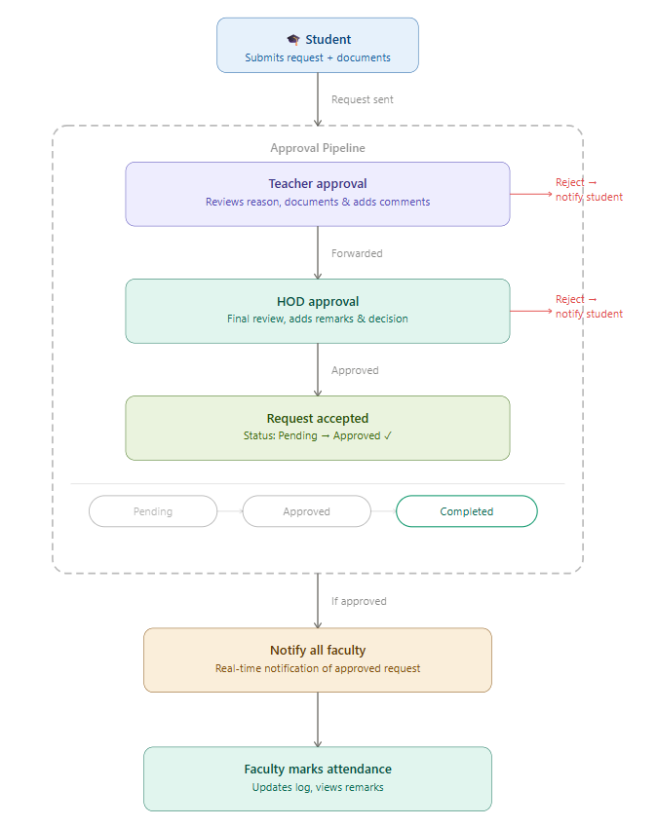

User

